

**The SDNA Lamplighter**

**November, 2016**   **Volume VII, Issue 3**

**SDNA**

**Shreveport District Nurses Association**

**Happy Thanksgiving to You and Yours! **

The SDNA Lamplighter is an electronic publication of the Shreveport District Nurses Association, under the direction of SDNA’s Communication and Public Relations Committee. For questions or to have information included in the Newsletter, please contact Diane Webb at [rhetton@aol.com](mailto:rhetton@aol.com) or at (318) 780-8473.



New Members – Please WELCOME:

Kelly Browning

Ginger Covington

Melinda Parnell

Shona Spillman

**This**

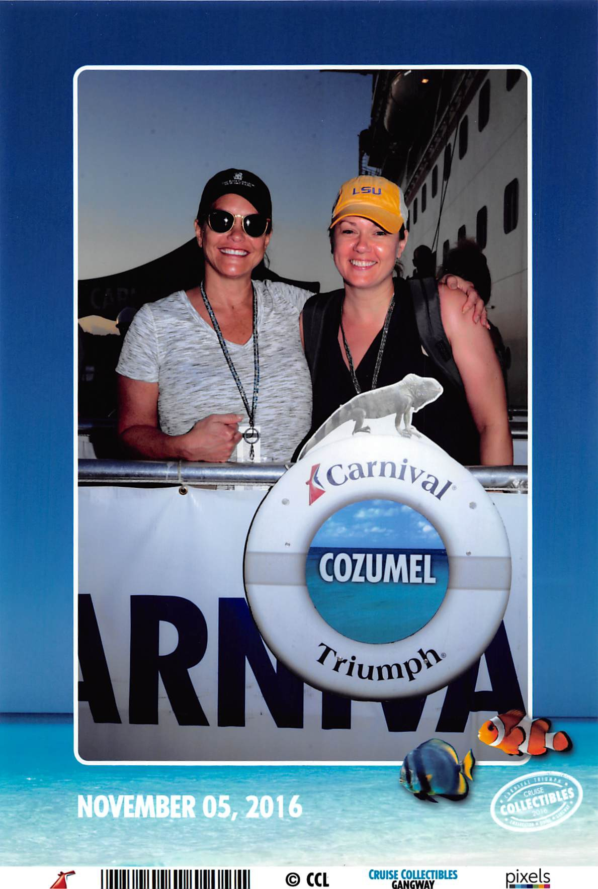

is **SHELLY HEBERT** enjoying her **free** LSNA CE Cruise to Cozumel Cozumel!!

But, next year **YOU** could be in this picture and on the

beach in Cozumel . . . how, you ask?

Just be a member of SDNA and attend the Nurse

of the Year Banquet in the Spring . . . your name

will automatically be entered into the drawing for the

cruise!

|  |  |  |  |  |  |  |  |  |
| --- | --- | --- | --- | --- | --- | --- | --- | --- |
| ***Proud to be an SDNA Member Profile: Melinda Parnell***  *I have been nursing all of my adult life! I began as an LPN in the early 80s at the young age of 18. I had the privilege to work at Doctors' Hospital and am very excited to see the building being resurrected for a rehab facility by the WK System. I received my ASN from La. Tech in '92 and my BSN in '06 and MSN in '11 from NSU. I taught LPNs through the technical college system for almost 10 years before I made the transition to NSU earlier this year. I love to teach! I love to share knowledge with my students. When I see in their faces that look of understanding and sense of accomplishment it raises my joy level 100% and makes all the work of teaching worthwhile.   I have a wonderful husband of 32 years (John), two teenagers (Thomas 15 & Sarah 13) and two fur babies. When time allows we go off together ANYWHERE we are able. There are those times that I simply run away with my girl friends for the weekend to scrapbook. A girl's got to do what a girl's got to do... Melinda Parnell.*  Thank you, Melinda, for being a member. We value your support, expertise and commitment to your profession!!    **Thank you, Veterans for your service to our country!**  **CALENDAR OF EVENTS**   |  |  |  |  | | --- | --- | --- | --- | | November 2016 C:\Users\Diane\AppData\Local\Microsoft\Windows\INetCache\IE\ROI99XDY\MC900439780[1].png | December 2016C:\Users\Diane\AppData\Local\Microsoft\Windows\INetCache\IE\8ZLN38V0\MC910215610[1].jpg | January 2017 | February 2017 | | 3-7 – LSNA CE Cruise **30 – SDNA BOD meeting, NSU @ 4:30 pm** | 3 – “A Clinical Ethics Workshop” at LSU Health Shreveport, main auditorium5 – Holiday No Host Social at Superior Bar & Grill at 6:00 pm. RSVP to Marilyn Barr at barrm@nsula.edu | 1 – New Year’s Day! **25 – SDNA BOD meeting, NSU @4:30 pm** | 14 – Valentine’s Day **22** **– SDNA BOD meeting, NSU 4:30 pm** 28 – FAT Tuesday |  Have You Heard?  **\*\*ANA Leadership Institute Webinar, Nurses in Health Policy: How and Why to Get Involved.** [**http://nursingworld.org/HomepageCategory/NursingInsider/ANA-Leadership-Institute-Webinar-11-09-16.html**](http://nursingworld.org/HomepageCategory/NursingInsider/ANA-Leadership-Institute-Webinar-11-09-16.html)  **\*\*ANA Ready to work with new administration to improve health for all.** [**http://nursingworld.org/HomepageCategory/NursingInsider/ANA-Ready-to-Work-with-New-Administration-to-Improve-Health-for-All.html**](http://nursingworld.org/HomepageCategory/NursingInsider/ANA-Ready-to-Work-with-New-Administration-to-Improve-Health-for-All.html)  **\*\*Call for applications ANA Moral Resilience Professional Issues Panel. Deadline is December 1.** [**http://nursingworld.org/HomepageCategory/NursingInsider/Call-for-Applications-ANA-Moral-Resilience-Professional-Issues-Panel.html**](http://nursingworld.org/HomepageCategory/NursingInsider/Call-for-Applications-ANA-Moral-Resilience-Professional-Issues-Panel.html)  **\*\*The LSNA Relief Fund is active! Donate to the fund to help Louisiana nurses impacted by the recent flood.** [**http://lsna.org/news.asp?intReleaseID=465&month=9&year=2016**](http://lsna.org/news.asp?intReleaseID=465&month=9&year=2016)  **\*\*Lisa Wilhite, SDNA Award Committee, is making plans to submit nominations for the 2016 *Annual Nightingale Awards* sponsored by the Louisiana Nurses Foundation. Each year the Foundations sponsors a Nightingale Gala in Baton Rouge to honor outstanding nurses in Louisiana. In 2016, SDNA would like to assist individuals in the northern part of the state to submit nominees in the following categories:**  **Advanced Practice Nurse**  **Clinical Nurse Researcher**  **Rookie Nurse**  **RN Mentor**  **Clinical Practice Nurse**  **Clinical Nurse Educator**  **Nursing Administrator**  **Outstanding Community Achievement by an RN**  **SON, Nursing Educator**  **SON, Nursing Administrator**  **Nursing School of the Year – Entry into Practice**  **LSNA Volunteer of the Year**  **Specialty Hospital**  **Acute Care Hospital**  **Registered Nurse of the Year**  **Traditionally, the southern part of the state submits many nominees for these awards; however, few, by comparison, are received from the parishes served by SDNA. Let’s change this . . . we have many professional nursing colleagues in our area who are so deserving of receiving these awards. Lisa and her committee are willing to assist you in documenting the required nominee packets. Packets are due in to the LSNA office by January 16, 2017 – our deadline for this project is almost upon us! Please contact Lisa Wilhite or any LSNA Officer or Board of Directors for further information.** Professional Development C:\Users\Diane\AppData\Local\Microsoft\Windows\Temporary Internet Files\Content.IE5\7864YXQV\MC900019306[1].wmf   **ANA** offers FREE ONLINE continuing education to its members! Go to:  <http://ananursece.healthstream.com/Pages/Category.aspx?category=FreeToMembers&cat=ANA&orderby=DisplayName&dir=ASC>  **MedscapeNurses** offers FREE ONLINE continuing education; you just have to sign up. Go to :  <http://www.medscape.org/>.  **WHO said IT? (Answer on last page)**  **“The character of the nurse is as important as the knowledge she possesses.”**  **Florence Nightingale?**  **Carolyn Jarvis?**  **Dr. Koop?**  **Donna Shalala?**  **C:\Users\Diane\AppData\Local\Microsoft\Windows\Temporary Internet Files\Content.IE5\5HI351SV\MC900023456[1].wmfClinical/Research**  **Dunn, D. (2016). Body art and the perioperative process. *AORN*, 104(4), p. 326-340.**  **Ewen, H., Nikzad-Terhune, K., Chahal, J. (2016). The rote administrative approach to death in senior housing: Using the other door. *Geriatric Nursing*, 37(5), p. 360-364.**  **Hall, E. & Cuellar, M. (2016). Immigrant health in the United States: A trajectory toward change. *Journal of Transcultural Nursing,* 27(6), 611-626, doi:10.1177/1043659616672534**  **Lusignani, M, Gianni, M, Re, L, & Buffon, M. (2016). Moral distress among nurses in medical, surgical, intensive-care units. *Journal of Nursing Management,* 24(8),  doi: 10.1111/jonm.12431**  **Links of Interest C:\Users\Diane\AppData\Local\Microsoft\Windows\Temporary Internet Files\Content.IE5\WTKI6JVA\MC900441338[1].png**  SDNA: <http://rhetton.wix.com/sdna-website>  LSNA: [www.lsna.org](http://www.lsna.org)  ANA: [www.nursingworld.org](http://www.nursingworld.org)  LSNA Legislative Resources: <http://www.lsna.org/legislative-links.html>  LSNA Nursing Resources: <http://www.lsna.org/resources.html>  The Online Journal of Issues in Nursing: <http://www.nursingworld.org/ojin/>  MDLinx site for Nursing Journals/Online Nursing Journals: <http://www.mdlinx.com/nursing/journals.cfm>  Sigma Theta Tau International: <http://www.nursingsociety.org/Pages/default.aspx>  **Legislative C:\Users\Diane\AppData\Local\Microsoft\Windows\Temporary Internet Files\Content.IE5\J4T8958D\MC900174327[2].wmf**    **Make plans to attend the SDNA Legislative Breakfast scheduled for Monday, April 3, 2017 at the NSU College of Nursing (please note this is a CHANGE OF VENUE!). More information will be forthcoming.**  LEGISLATIVE RESOURCES  [Agency for Healthcare Policy and Research](http://www.ahrq.gov/)  [American Nurses Association Government Affairs](http://www.nursingworld.org/MainMenu.Categories/ANAPoliticalPower.aspx) [Locate your U.S. Representative](http://www.house.gov/) [Locate your U.S. Senator](http://www.senate.gov/) [Louisiana Legislature](http://www.legis.state.la.us/)  **SDNA OFFICERS and BOARD OF DIRECTORS (2016-2017)**  **Officers:**  **President: Debra Clark, Northwestern State University**  **President-Elect: Tamny Randol, Willis Knighton Health System**  **Immediate Past President: Susan Edwards, Overton Brooks VA Medical Center**  **Vice-President: Heather Hayter**, **Northwestern State University**  **Secretary: Dianna Hill, Northwestern State University**  **Treasurer: Marilyn Barr, Northwestern State University**  **Board of Directors:**  **Tamara Baxter, Northwestern State University**  **Micki Browning, Willis Knighton Health System**  **Patrice Gilbert, Willis Knighton Health System**  **Jo Sellers, Willis Knighton Health System**  **Diane Webb, Retired, Northwestern State University**  **Lisa Wilhite, (Awards Chair)**  **Maxine Johnson, Northwestern State University**  **\*\*Have ideas, suggestions, or information that you would like to share via the SDNA Lamplighter? Please contact Diane Webb via email at** [**rhetton@aol.com**](mailto:rhetton@aol.com) **or by phone at (318) 780-8473.**  Thanks to **Pamela Simmons** and **Dianna Hill** for serving on the Communications and Public Relations Committee  *Answer to Who Said it? – Carolyn Jarvis. |