

**The SDNA Lamplighter**

**April, 2017**  **Volume III, Issue VIII**

**SDNA**

**Shreveport District Nurses Association**



*The SDNA Lamplighter is an electronic publication of the Shreveport District Nurses Association, under the direction of SDNA’s Communication and Public Relations Committee. For questions or to have information included in the Newsletter, please contact Diane Webb at* [*rhetton@aol.com*](mailto:rhetton@aol.com) *or at (318) 780-8473.*

**SDNA Hosts Legislative Breakfast **

Fifty-one area nurses, legislators and other health care professionals attended SDNA’s Legislative Breakfast on Monday, April 1, 2017. The breakfast was held at Northwestern State University’s Nursing Education Center in Shreveport. Decorations included blue tablecloths, red napkins, American flags, and red roses. A delicious buffet, prepared by Marilyn Barr, SDNA Treasurer, and Tamara Baxter, SDNA Board Member, enticed attendees with fresh fruit, biscuits, egg and ham cups, sausage, cheese grits, hash brown casserole, and a delicious caramel pecan bread pudding. Coffee and various fruit juices completed the menu.

SDNA President Debra Clark was Mistress of Ceremonies and Maxine Johnson, SDNA Nominating Chair, presented a program on the “Economic Impact of Registered Nurses in Northern Louisiana.” Norlyn Hyde, LSNA President, delivered greeting from LSNA. Area legislators and elected officials were introduced, given the opportunity to share their thoughts and views on the upcoming legislative session, and responded to questions posed by attendees. The program awarded 1.25 contact hours for successful completion.

A special “thank you” is extended to Marilyn, Tamara, Maxine, all SDNA Officers and Board Members for the time and energies they devoted to this project. In addition, we would like to thank Dr. Dana Clawson, Dean of the College of Nursing and School of Allied Health at Northwestern, and Heather Hayter, Assistant Professor of Nursing for their assistance with this endeavor.

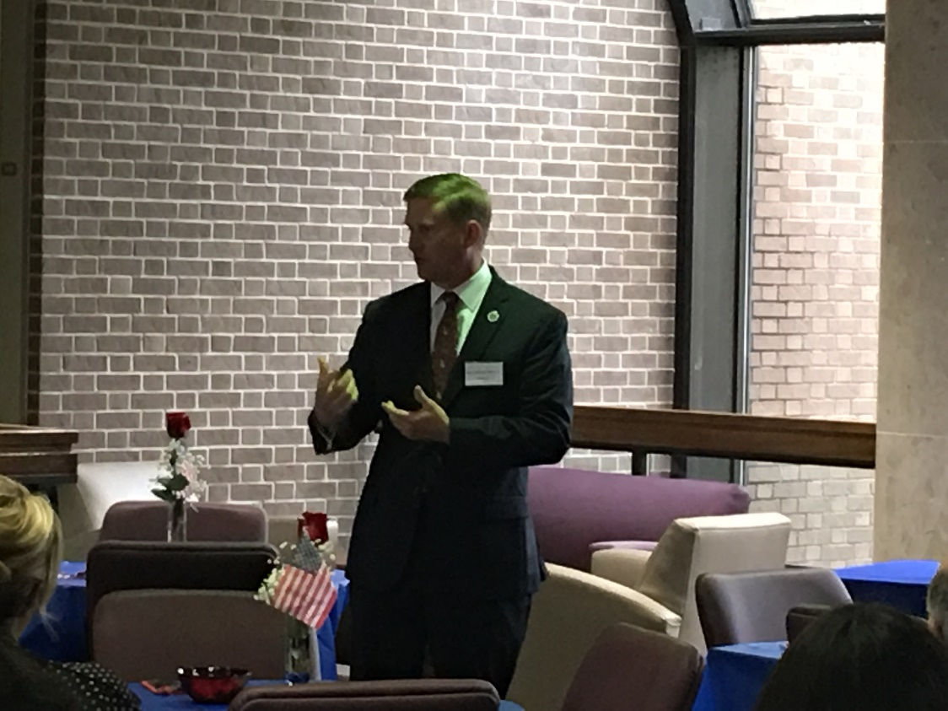

Senator Barrow Peacock addresses attendees at the SDNA Legislative Breakfast

**Guess WHO Said It? \***

“*I attribute my success to this . .* *. I never gave or took any excuse.”*

*Cherry Ames?*

*Clara Barton?*

*Florence Nightingale?*

*(*answer on last page of newsletter)*



**SDNA would like to welcome the following new members . . . glad to have you as a member of the profession and the organization!**

**Cassandra Pollard**

**Kathleen Redler**

**ANA/LSNA/SDNA Needs Your Help!**

**As a member of ANA/LSNA/SDNA, you recognize the invaluable contribution these entities make to the profession of nursing. ANA/LSNA/SDNA are the only professional organizations that speak for all registered nurses, no matter their specialty area. Have you thought about educating your non-member colleagues about the benefits of membership? Just think . . . an online education resource center, fact sheets and resources, professional tools, ANA periodicals, networking, member discounts, free nursing continuing education (including webinars), and participation at the local, state, or national level to impact the profession. Why, we’re the best value in town! An excellent resource for membership benefits can be found on LSNA’s website at** [**http://www.lsna.org/benefits.html**](http://www.lsna.org/benefits.html)**. Here’s a link to the membership application:** [**http://lsna.org.mytempweb.com/PDFs/membershipapplication.pdf**](http://lsna.org.mytempweb.com/PDFs/membershipapplication.pdf)

**Introducing Your Newly Elected SDNA Officers and Board of Directors:**

**Vice-President Heather Hayter, Northwestern State University**

**Treasurer Marilyn Barr, Northwestern State University**

**Board Member Diane Webb, Retired, Northwestern State University**

**Board Member Danita Potter, Northwestern State University**

**Board Member Shelly Hebert, Gia Kosmitis Law Office**

**New officers and board members will be installed at the Nurse of the Year Banquet on May 9th at Sam’s Town. A transition Board meeting will be held at Northwestern State University on June 28, 2017 at 4:30 pm.**

|  |  |  |  |  |  |  |  |
| --- | --- | --- | --- | --- | --- | --- | --- |
| **CALENDAR OF EVENTS**   | April 2017 | May 2017 | June, July & August 2017 | | --- | --- | --- | | **1 – LNF Nightingale Gala, Baton Rouge**  **3 – SDNA Legislative Breakfast**  **23 – ANCC CNE Update for LSNA Approver Units/Individual Educational Activity Applicants, Baton Rouge**  **24 – 25 LSNA Convention/HOD/Legislative Update, Baton Rouge**  **28 – SDNA BOD Meeting, NSU** | **9 – Nurse of the Year Banquet, Sam’s Town Casino** | Enjoy your summer! The SDNA Lamplighter will resume in the Fall! |  Have You Heard?  You can access SDNA’s new website at <https://www.shreveportdistrictnursesassociation.com/>. Thanks to Patrice Gilbert for implementing this new website!!!  The LSNA Approver/Provider Units have a new email address! Contact [nursingeducation@lsna.org](mailto:nursingeducation@lsna.org) for information on Approver and Provider application processes.  Nurses’ Week Theme Announced: The theme for Nurses’ Week, May 6 – 12, 2017 will be “Nursing: the Balance of Mind Body, and Spirit”. You can access the National Nurses Week 2017 Logo Library at <http://nursingworld.org/NNW-2017LogoLibrary>. The Resources Toolkit may be downloaded at <http://nursingworld.org/FunctionalMenuCategories/National-Nurses-Week-2017/NNW-Toolkit>.  American Nurses Association and Hospice & Palliative Nurses Association Call for Palliative Care in Every Setting. <http://nursingworld.org/HomepageCategory/NursingInsider/American-Nurses-Association-and-Hospice-Palliative-Nurses-Association.html> Professional Development C:\Users\Diane\AppData\Local\Microsoft\Windows\Temporary Internet Files\Content.IE5\7864YXQV\MC900019306[1].wmf   ANA: New online course alert! Fundamentals of Nurse Staffing: Building an Optimal Staffing Model.  <http://nursingworld.org/HomepageCategory/NursingInsider/Fundamentals-of-Nurse-Staffing-Building-an-Optimal-Staffing-Model.html>  ANA: ANCC Pathway to Excellence Conference, Dallas, Texas, April 27 & 28. <http://nursingworld.org/HomepageCategory/UpcomingEvents/ANCC-Pathway-to-Excellence-Conference.html>  ANCC CNE Update for LSNA Approver Units/Individual Educational Activity applicants. Sunday, April 23 at Holiday Crowne Plaza, Baton Rouge. [**https://events.r20.constantcontact.com/register/eventReg?oeidk=a07edrq9iwgfda599cf&oseq=&c=&ch**](https://events.r20.constantcontact.com/register/eventReg?oeidk=a07edrq9iwgfda599cf&oseq=&c=&ch)**=**  LSNA Convention/HOD/Legislative Update, April 24 & 25 at Holiday Crowne Plaza, Baton Rouge.  ANA Webinar Series: *How to Thrive in Your First Year as an RN: How to Protect Your RN License.*  Start Date: 6/7/2017 12:00:00 PM  End Date: 6/7/2017 1:30:00 PM  Location: Webinar FREE! [**https://event.on24.com/eventRegistration/EventLobbyServlet?target=reg20.jsp&referrer=&eventid=1375765&sessionid=1&key=689BCF3127E41247B0105835480C8E2B&regTag=&sourcepage=register**](https://event.on24.com/eventRegistration/EventLobbyServlet?target=reg20.jsp&referrer=&eventid=1375765&sessionid=1&key=689BCF3127E41247B0105835480C8E2B&regTag=&sourcepage=register)  ANA offers FREE ONLINE continuing education to its members! Go to:  <http://ananursece.healthstream.com/Pages/Category.aspx?category=FreeToMembers&cat=ANA&orderby=DisplayName&dir=ASC>  MescapeNurses offers FREE ONLINE continuing education; you just have to sign up. Go to :  <http://www.medscape.org/>.  C:\Users\Diane\AppData\Local\Microsoft\Windows\Temporary Internet Files\Content.IE5\5HI351SV\MC900023456[1].wmfClinical/Research  Ali, S., & Seiloff C. (2017). Nurse’s use of power to standardize nursing terminology in electronic health records. *Journal of Nursing Management*, 25(3), 163-166.  Clark, A., Glazer, G., Edwards, C. (2017). Transforming nursing education with Apple technology. *Nurse Educator*, 42(4), 91-94.  Hendrix, L. & Winters, C. (2017). Continuing education for critical care nurses in rural or remote settings. *Critical Care Nurse*, 37(2), 66-71.  Zhu, N., Xu, P., Lei, T., Sun, T., & Chan, S. (2017). Post operative pain self-management behavior in patients who underwent total knee or hip arthroplasty. *AORN Journal*, 105(4), 355-364.   |  | | --- | |  |   C:\Users\Diane\AppData\Local\Microsoft\Windows\Temporary Internet Files\Content.IE5\WTKI6JVA\MC900441338[1].pngLinks of Interest  SDNA website: <https://www.shreveportdistrictnursesassociation.com/>  SDNA Facebook page: <https://www.facebook.com/search/str/Shreveport+district+nurses+association/keywords_top>  LSNA: [www.lsna.org](http://www.lsna.org)  LSNA Facebook page: <https://www.facebook.com/LouisianaStateNurses/>  ANA: [www.nursingworld.org](http://www.nursingworld.org)  LSNA Legislative Resources: <http://www.lsna.org/legislative-links.html>  LSNA Nursing Resources: <http://www.lsna.org/resources.html>  The Online Journal of Issues in Nursing: <http://www.nursingworld.org/ojin/>  MDLinx site for Nursing Journals/Online Nursing Journals: <http://www.mdlinx.com/nursing/journals.cfm>  Sigma Theta Tau International: <http://www.nursingsociety.org/Pages/default.aspx>  Legislative C:\Users\Diane\AppData\Local\Microsoft\Windows\Temporary Internet Files\Content.IE5\J4T8958D\MC900174327[2].wmf  The 2017 Regular Legislative Session will convene at noon on Monday, April 10, 2017.   Final Adjournment no later than 6:00 pm on Thursday, June 8, 2017.  To search for a particular bill in the 2017 Legislative Session: <http://www.legis.la.gov/legis/BillSearch.aspx?sid=17RS>  Be sure to access the LSNA Billtracker at the following site: <http://www.lsna.org/billtracker.xls>  frequently for updates on House and Senate bills affecting healthcare and nursing in the state of Louisiana. In addition, you will find LSNA’s position on each of these bills . . . the site indicates whether LSNA is (l) monitoring a bill, (2) in support of a bill, or (3) opposed to a bill.  LSNA’s Health Policy Chair is Patricia LaBrosse from the Lafayette District Nurses’ Association; she is also a member of the LSNA Board of Directors. LSNA’s Lobbyist is Randall Johnson with Southern Stragegies in Baton Rouge. SDNA’s Health Policy Chair is Patrice Gilbert.  LEGISLATIVE RESOURCES  [Agency for Healthcare Policy and Research](http://www.ahrq.gov/)  [American Nurses Association Government Affairs](http://www.nursingworld.org/MainMenu.Categories/ANAPoliticalPower.aspx) [Locate your U.S. Representative](http://www.house.gov/) [Locate your U.S. Senator](http://www.senate.gov/) [Louisiana Legislature](http://www.legis.state.la.us/) SDNA OFFICERS and BOARD OF DIRECTORS (2014-2016) **Officers:**  President: Debra Clark, Northwestern State University President-Elect: Tamny Randol, Willis Knighton Health System  Immediate Past President: Susan Edwards, Overton Brooks VA Medical Center  Vice-President: Heather Hayter, Northwestern State University  Secretary: Dianna Hill, Northwestern State University  Treasurer: Marilyn Barr, Northwestern State University  **Board of Directors:**  Tamara Baxter, Northwestern State University  Micki Browning, Willis Knighton Health System  Patrice Gilbert, Willis Knighton Health System  Jo Sellers, Willis Knighton Health System  Diane Webb, Retired, Northwestern State University  Maxine Johnson, Northwestern State University  Vacant Position, (Awards Chair)  **\*Answer to Guess WHO Said It?: Why, Miss Florence, or course!**  **Have ideas, suggestions, or information that you would like to share via the SDNA Lamplighter?  Please contact Diane Webb via email at [rhetton@aol.com](mailto:rhetton@aol.com) or by phone at (318) 780-8473.  **Thanks to Pamela Simmons, Dianna Hill, and Maxine Johnson for serving on the Communications and Public Relations Committee** |
|  |